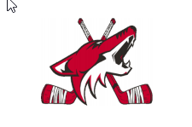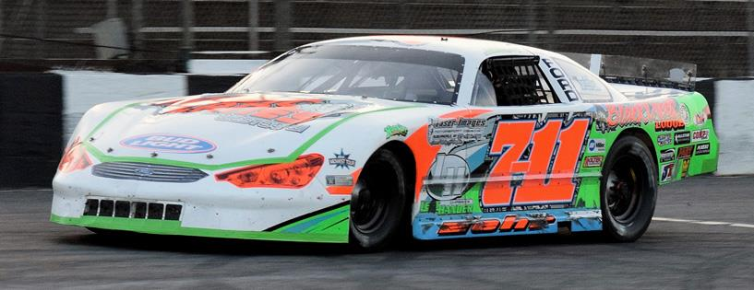

**Redline Speedsports** **Annual Fundraiser**

**Portions of the proceeds from this year’s fundraiser will go to the Clark County Youth Hockey program in support of their building project.**

**9-Pin Tap Bowling**

**Tournament**

STRIKETIME LANES

NEILLSVILLE, WI

SATURDAY, MARCH 25

FUN – FUN - FUN

**Silent Auction**

**Raffles**

**50/50 Drawings**

**Grand Prize Drawing**

**Payout to Top 3 Men & Women**

**Annual Redline Speedsports Fundraiser**

$30 per Bowler – Must RSVP with $15 Down per Bowler to hold your spot.

Please call for availability of shifts.

|  |  |  |  |  |
| --- | --- | --- | --- | --- |
| **Preferred Shift: ____ 3PM ____ 6PM ____ No Preference** (if needed, 12noon shift will be added) | | | | |
| **Bowler Name** | | **Average** | **$ Down** | **$ Due 3/20** |
|  | |  |  |  |
|  | |  |  |  |
|  | |  |  |  |
|  | |  |  |  |
|  | |  |  |  |
| **Team Contact:** | **Phone:** | **Total:** |  |  |

FOR MORE INFORMATION, PLEASE CONTACT WAYNE BREVIK AT: [wbrevik@redlinespeedsports.com](mailto:wbrevik@redlinespeedsports.com) or 715-533-0796

Mail this form with your full entry fee or $15 down per bowler to:

REDLINE SPEEDSPORTS, P.O. BOX 68, FAIRCHILD, WI 54741

*Portion of the proceeds will be donated to the Clark County Youth Hockey Program.*